**Final Project**

**STAT 7122/8122, Fall 2018**

**Sagar Satyanarayana**

**Q1)**

* **631** patients died within three years of myocardial infraction.
* **179** patients died within one month of myocardial infraction.
* **51.118 %** patients are censored in this dataset.

**Q3) Estimated cumulative coefficients along with 95% confidence intervals:**

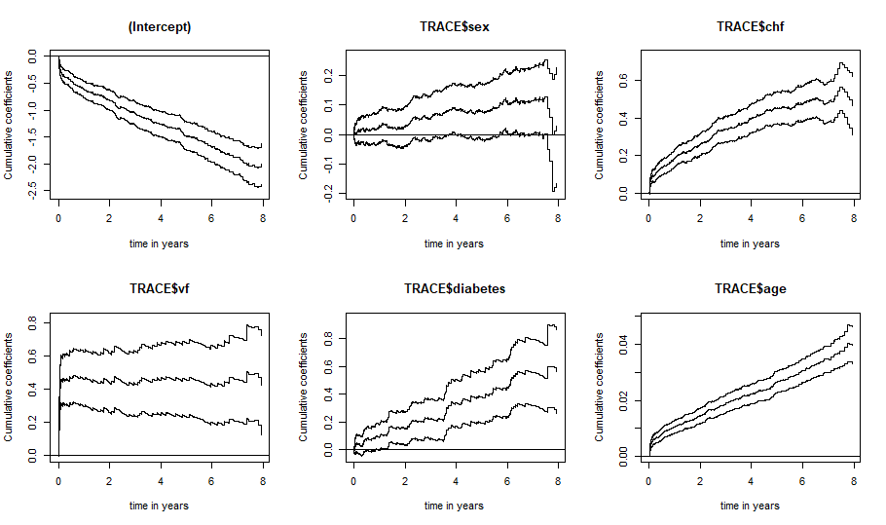

**Q4)**

Kolomogororov-Smirnov and Cramer von mises tests are used to test if the effects are constant or time-varying. With the null hypothesis; **H0: effects are not time-varying (effects are constant).**

**Kolomogororov-Smirnov test**

**Constant effects**

Kolmogorov-Smirnov test p-value H_0: constant effect

sex 0.10100 0.298

diabetes 0.10700 0.613

**Time-varying effects**

Kolmogorov-Smirnov test p-value H_0: constant effect

chf 0.17600 0.001

vf 0.46100 0.000

age 0.00584 0.012

**Cramer von mises test**

**Constant effects**

Cramer von Mises test p-value H_0: constant effect

sex 2.94e-02 0.168

diabetes 1.22e-02 0.780

**Time-varying effects**

Cramer von Mises test p-value H_0: constant effect

chf 1.39e-01 0.000

vf 5.84e-01 0.000

age 7.72e-05 0.026

**Q5)** Sex and diabetes are modeled as constant effects. Clinical Heart Failure (chf), Ventricular Fibrillation (VF) and age are modeled as time-varying effects.

Estimates for constant effects with 95% confidence interval

Estimate lower 2.5% upper 97.5%

Sex 0.0159 -0.00129 0.0331

Diabetes 0.0808 0.04570 0.1160

**Cumulative time-varying effects with 95% confidence intervals:**

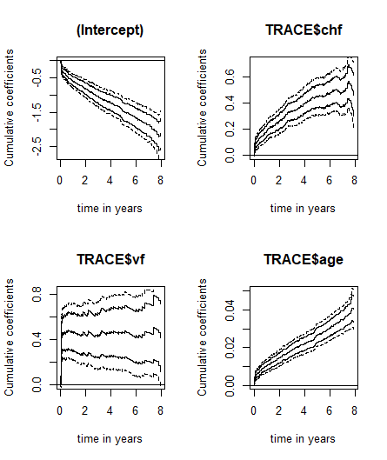

**Q6)**

Supremum-test of significance is used to test if the time-varying effects: Clinical Heart Failure (chf), Ventricular fibrillation (VF) and age has significant effect on myocardial infraction related mortality. The null hypothesis; **H0: Covariates have no significant effect on mortality**. The p-values below 0.05 indicate all three covariates have significant effect on myocardial infraction related mortality.

**Significant effects on myocardial infection**

Supremum-test of significance p-value H_0: B(t)=0

chf 10.10 0

vf 6.53 0

age 14.80 0

**Q7)**

Sex and diabetic condition of the patients from the study are found to be constant covariates that significantly affect the myocardial infraction related mortality and their effects do not vary with time. Whereas chf, vf and age are time-varying effects. The effects chf and age has on myocardial infraction seems to increase steadily with time, these have more effect on mortality as the time from infection increases. Vf however, seem to have very little effect at the onset of the disease (around time 0 to few months), but increases steeply after certain number of days within a few months after the onset of the disease.

**Q8)**

**Cumulative residuals versus age:**

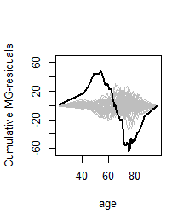

Model does not seem to fit well as the plot of age seems to move away from the cumulative residuals. Using a semi-parametric model while modelling both constant and time-varying effects will improve the fit.

**Cumulative residuals versus age (split into: lower, middle and upper):**

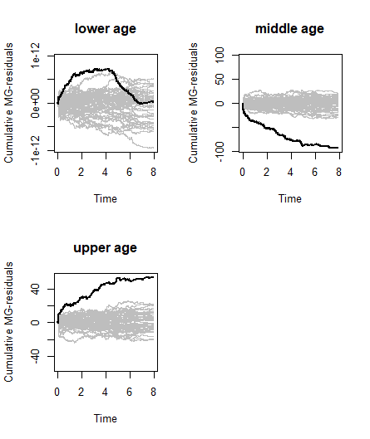

There seems to be no improvement in the model fit even after splitting the age into 3 groups; as the plots are still away from the cumulative residuals.